Software Requirement Specifications
Enhancing Data Quality in Student Records Using Python-Based Data Cleaning Pipelines



Submitted by
Maryam Ahmad
F22BINFT1M01117

Submitted to
Dr. Mustafa Hameed

Department of Information Technology
Faculty of Computing
The Islamia University of Bahawalpur

Meeting Details
Sr No | Details | Date | Supervisor Signature
1. | Project Topic Assignment & Project Proposal Submission | Fri 7 Nov, 2025
2. | Introduction to Software Requirement Specifications (SRS) | Wed 12 Nov, 2025
3. | Detailed discussion on Software Requirement Specifications (SRS) | Wed 26 Nov, 2025
4. | Finalization of SRS Document | Wed 3 Dec, 2025

Summary
The Software Requirements Specification (SRS) document defines the goals, requirements, and technical aspects of the project titled “Enhancing Data Quality in Student Records Using Python-Based Data Cleaning Pipelines.” The project aims to address the recurring challenges of inaccurate, inconsistent, and incomplete student data in academic institutions by developing a Python-driven automated data cleaning pipeline.
This system will detect and handle missing values, remove duplicate records, standardize data formats, and generate comprehensive reports on data quality improvement. By leveraging Python’s data science libraries, the project ensures a reliable and efficient data validation and cleaning process that enhances data integrity for educational databases.
Table of Contents
1. Introduction 4
1.1. Purpose 4
1.2. Scope 5
1.3. Product Perspective 5
1.4. User Characteristics 5
1.5. Similar apps and systems/Literature Review 6
1.6. Proposed Technologies 6
2. Requirements 6
2.1. Function Requirements 6
2.1.1. Data Upload 6
2.1.2. Data Validation 7
2.1.3. Data Cleaning 8
2.1.4. Generate Data Quality Report 8
2.2. Non-Functional Requirements 9
3. Use Cases and Flow of Processes 9
3.1. Use Case 1 10
4. References 13

- Introduction

Educational institutions store vast amounts of student-related data, often collected from multiple sources. Such data is prone to inconsistencies, missing values, and duplication, leading to inaccurate reporting and decision-making. This project introduces a Python-based data cleaning pipeline that automatically enhances the quality of student records by integrating processes for validation, cleaning, and reporting.

The system provides a user-friendly interface where administrators and data analysts can upload datasets, validate data, clean records, and generate reports summarizing improvements.
  - Purpose
The purpose of this project is to design and develop an automated data cleaning pipeline that improves the accuracy, consistency, and completeness of student record data using Python programming.
Key objectives include:
- Detecting and correcting missing, inconsistent, or invalid data.
- Removing duplicate entries from datasets.
- Standardizing formats for names, IDs, and contact information.
- Generating detailed reports summarizing the data quality improvements.
Ultimately, the project aims to help educational organizations maintain reliable, analytics-ready data with minimal human intervention.
  - Scope
The project’s scope covers:
- Uploading student record files (CSV/Excel).
- Automatically validating data entries for accuracy and completeness.
- Cleaning data through a structured Python pipeline.
- Generating summary reports on corrections, duplicates, and overall quality metrics.
Out of Scope:
- Integration with external university databases or APIs.
- Real-time or cloud-based data streaming.
- Manual data entry interfaces (system uses pre-existing files).

  - Product Perspective

This product functions as a standalone desktop-based data quality enhancement tool, which can later be integrated into Student Information Systems (SIS). It uses a pipeline architecture, where uploaded data sequentially passes through stages—validation, cleaning, and reporting—automating what would otherwise be a manual and error-prone process.

User Characteristics
User Type | Description | Technical Expertise
Admin | Oversees the process, uploads data, and reviews reports. | Intermediate
Data Analyst |  | Advanced
  Interprets data quality reports and ensures accuracy.
Staff User | Uploads raw data files for validation and cleaning. | Basic

  - Similar apps and systems/Literature Review

Similar tools like OpenRefine, Excel Data Validation, and Google DataPrep offer general-purpose cleaning but lack customization for educational data structures.
Academic studies (e.g., Kumar et al., 2021, Journal of Data Science) highlight that Python’s Pandas, NumPy, and Scikit-Learn libraries provide superior flexibility for structured data cleaning pipelines.

This project differentiates itself by focusing specifically on student data and automating the entire cleaning process from upload to final report generation using a modular Python-based architecture.
  - Proposed Technologies
- Programming Language: Python
- Frameworks/Libraries: Pandas, NumPy, OpenPyXL, Matplotlib, Scikit-Learn (for anomaly detection)
- Storage: CSV / SQLite (optional)
- IDE: Jupyter Notebook / Visual Studio Code
- Version Control: GitHub

- Requirements
The Python-based pipeline will automatically process uploaded datasets through four primary stages: Upload, Validate, Clean, and Report. Each stage is implemented as a functionally independent module to ensure modularity and scalability.

  - Function Requirements

2.1.1 Data Upload
- Name: FR001
- Purpose:
The data upload process allows the user to import raw student record files (in CSV or Excel format) into the Python-based pipeline. This step initializes the entire cleaning process by loading the dataset for validation and cleaning.
- User(s): Admin, Staff User
- Input:
  - File path or file selection through the upload interface
  - Accepted file formats: .csv, .xlsx
  - File must contain defined columns (e.g., Roll No, Name, Department, Contact, Grades)
- Output:
  - A preview of the uploaded data is displayed for confirmation
  - Message: “File uploaded successfully” or error message for invalid file format.

2.1.2 Data Validation
- Name: FR002
- Purpose:
The data validation module checks uploaded data for missing, inconsistent, or invalid entries. It ensures all fields meet the required data standards before cleaning begins.
- User(s): Admin, Data Analyst
- Input:
  - Uploaded dataset from FR001
  - Predefined validation rules (e.g., no empty Roll No, numeric grades, valid email format)
- Output:
- Validation summary table displaying:
    - Number of missing values
    - Invalid field formats
    - Datasets requiring correction
- Validation report (CSV or console log)

2.1.3 Data Cleaning
- Name: FR003
- Purpose:
This module executes the Python-based data cleaning pipeline that fixes identified issues from the validation stage. It removes duplicate entries, fills missing fields (using defined strategies), and standardizes data formats (like capitalizing names, formatting IDs, and normalizing course codes).
- User(s): Admin
- Input:
  - Validated dataset from FR002
  - Cleaning parameters (e.g., remove duplicates based on Roll No, standardize name case, etc.)
- Output:
  - Cleaned dataset with:
    - Missing values handled
    - Duplicates removed
    - Standardized formats applied
  - Log file showing summary of all cleaning actions performed

2.1.4 Generate Data Quality Report
- Name: FR004
- Purpose:
To generate a comprehensive visual and textual report showing improvements made through the data cleaning pipeline. The report summarizes data accuracy, completeness, and consistency levels before and after cleaning.
- User(s): Admin, Data Analyst
- Input:
  - Cleaned dataset from FR003
  - User requests to generate a report
- Output:
  - Report (PDF/CSV) including:
    - Total records processed
    - Number of errors fixed
    - Duplicates removed
    - Missing fields corrected
    - Overall Data Quality Score (%)
  - Visual charts generated using Matplotlib for better interpretation
  - Non-Functional Requirements

  Requirement Type
  Description
 | Processes up to 10,000 records in under 10 seconds.
  Performance
 | Simple GUI for non-technical users.
  Usability
  Reliability
  Ensures 95% accuracy in data validation and cleaning.
 | Runs on Windows, macOS, and Linux.
  Portability
 | Data is processed locally; no cloud storage.
  Security
  Scalability
  Modular architecture for easy expansion.

- Use Cases and Flow of Processes

System Level Use Case Diagram
Actors: Admin, Data Analyst, Staff user
Use Cases: Upload Data, Validate Data, Clean Data, Generate Report
Process Flow:
Upload Data → Validate Data → Clean Data → Generate Report

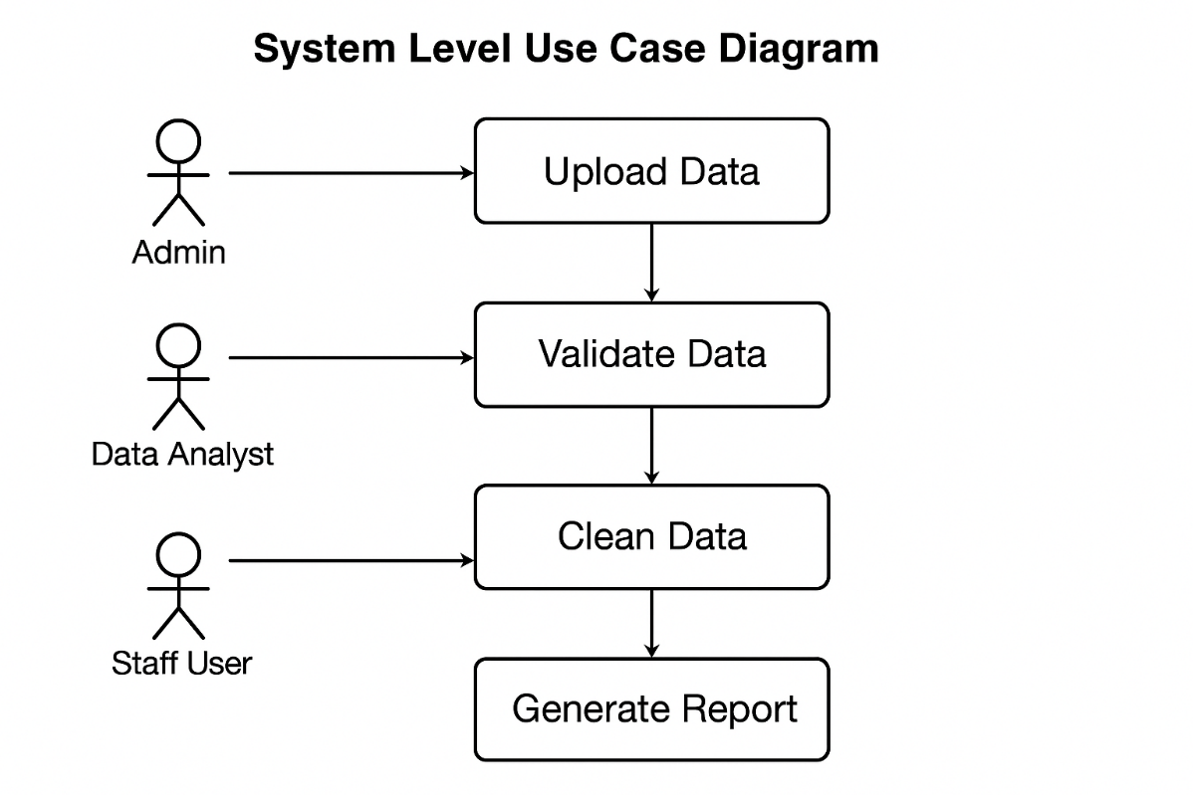
  - Use Case 1
ID | UC001
Name | System Level Use Case Diagram
Description | This use case diagram illustrates the interaction between the main system actors — Admin, Data Analyst, and Staff User — and the core functionalities of the Python-based data cleaning pipeline: Upload Data, Validate Data, Clean Data, and Generate Report. It defines how each user participates in improving the accuracy, consistency, and reliability of student records through automated data cleaning.
Requirement(s) | FR001, FR002, FR003, FR004
Actor(s) | Admin, Data Analyst, Staff User
Precondition
  The system is installed, and users are authenticated with assigned roles. Input student record files are available for upload.
Postcondition | Users can complete their respective operations. The system enhances data quality by validating, cleaning, and reporting results accurately.
Basic Flow | Basic Flow  - Admin logs into the system and uploads student record files (CSV/Excel).  - The system accepts the file and proceeds to Validate Data, checking for missing values, invalid formats, and inconsistent entries.  - Admin or Data Analyst reviews validation results and initiates the Clean Data process.  - The system executes the Python-based data cleaning pipeline, which removes duplicates, fills missing fields, and standardizes data formats (e.g., capitalization, numeric consistency).  - Once cleaning is complete, the Generate Report module is triggered.  - The system produces a visual and textual Data Quality Report summarizing:  - Errors fixed  - Duplicates removed  - Standardization actions applied  - Overall Data Quality Score (%)  - Data Analyst reviews, interprets, and exports the final report as a CSV or PDF file.  - Staff User may upload additional datasets for validation and cleaning through the same process, ensuring continuous data quality improvement.  Alternative Flow  - If the uploaded file is incorrectly formatted or missing required columns, the system displays an error message and prompts re-upload.  - If the validation or cleaning pipeline encounters an error, it logs the issue and generates a detailed error report for the Admin.  - If the report cannot be generated (e.g., insufficient data cleaned), the system notifies the user and halts the process safely.  Exceptions  - Upload failure due to invalid file type or missing columns.  - Missing Python dependencies (e.g., Pandas, NumPy not installed).  - Report generation failure due to storage issues or system permissions.  - Data corruption detected during validation or cleaning.

Diagrams
The use case 1 diagram is as follows:
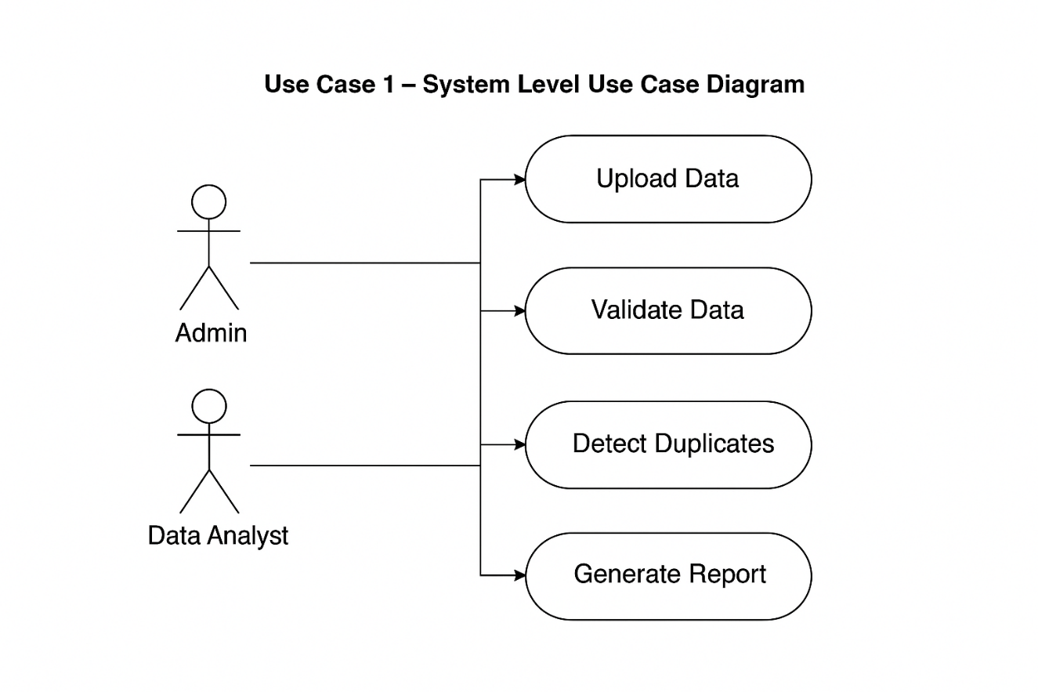
- References
- [1] W. McKinney, Python for Data Analysis, 3rd ed. Sebastopol, CA, USA: O’Reilly Media, 2022.
- [2] OpenRefine Documentation. [Online]. Available: https://openrefine.org
- [3] Pandas Library Documentation. [Online]. Available: https://pandas.pydata.org
- [4] A. Kumar, R. Singh, and P. Sharma, “Data Cleaning Approaches for Improving Data Quality,” Journal of Data Science, vol. 19, no. 4, pp. 112–123, 2021.
- [5] Scikit-Learn User Guide. [Online]. Available: https://scikit-learn.org

